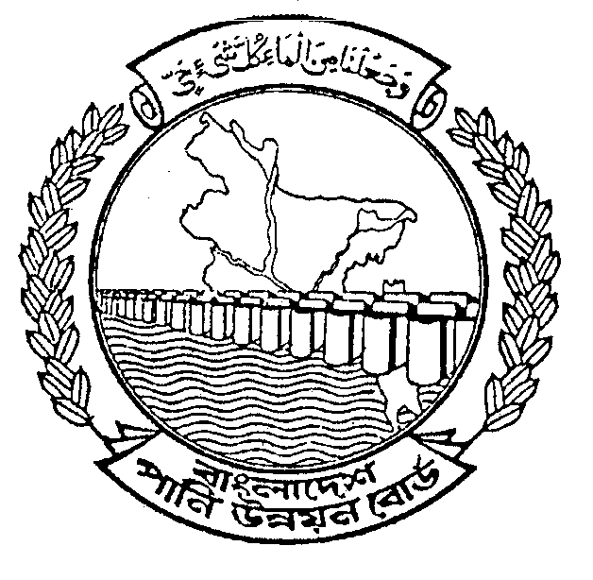
BANGLADESH WATER DEVELOPMENT BOARD
OFFICE OF THE
EXECUTIVE ENGINEER
BARISAL O&M DIVISION, BARISAL

INVITATION FOR TENDER

TENDER NOTICE NO. 01 /2011-2012.
(EMERGENCY)

GOVERNMENT OF THE PEOPLE’S REPUBLIC OF BANGLADESH
1 | Ministry/Division | Ministry of Water Resources.
2 | Agency | Bangladesh Water Development Board.
3 | Procuring Entity Name | Executive Engineer, Barisal O&M Division, BWDB, Barisal.
4 | Procurement Entity code | -
5 | Procuring Entity District | Barisal
6 | Invitation for | Emergency Temporary protective work.
7 | Invitation Ref. No. | Memo No.T-3/ 1392(100)
8 | Date | 28-07-2011.
KEY INFORMATION
9 | Procurement Method | Open Tender Method (OTM)
FUNDING INFORMATION
10 | Budget and Source of Funds | GOB (Non-Development Revenue Budget).
11 | Development Partners  (if applicable) | Not applicable.
PARTICULAR INFORMATION
12 | Project Code (if applicable) | Not applicable.
13 | Project name. | Emergency Temporary Protective work to protect the Ulania-Gobindapur Bazar & Launchghat area from erosion of Meghna River.
14 | TENDER PACKAGE No. | 01(one) No.
15 | Tender package name | (i) PACKAGE NO. BSL-MEH-01
16 | Tender Publication date | -
17 | Tender Last selling date& time. | 17-08 - 2011 Office hours.
18 | Tender closing date & time | 18-08-2011 up to 12.00 hours (Noon).
19 | Tender Opening Date &  time | 18-08-2011 at 12.30 hours.
20 | Name & Address of the office(s)  -Selling tender document  (Principal) | Sonali Bank Ltd, Sagardi Branch, Barisal.
20 | - Selling tender document others | Rupali Bank Ltd, Sagardi Branch, Barisal.  Janata Bank Ltd. Dilkusha Corporate Branch, 29, Dilkusha C/A, Dhaka.
20 | - Receiving tender document. | Office of The Executive Engineer, Barisal O&M Division, BWDB, Barisal.
20 | - Opening tender document | The Executive Engineer, Barisal O&M Division, BWDB, Barisal.
21 | Place/Date/Time of Pre-  Tender Meeting(optional) | Not applicable.

-2-

INFORMATION FOR TENDERER
22 | Eligibility of Tenderer |  |  |  | All Elegible Tenderer as per “The Public Procurement Regulation, 2008”
23 | Brief Description of works
Sl. No. | Identification of Package/Lot No. |  |  | Brief Description of works |  |  | Location  Upazilla/  District | Price of Tender Document (Tk) | Tender security amount in (Tk) | Completion  time in week/months
(1) | (2) |  |  | (3) |  |  | (4) | (5) | (6) | (7)
1. | BSL-MEH-01 |  |  | Supplying empty Geo-textile Bags (175 Kg), Filling & Dumping Geo-Textile bags (175kg) for Emergency Temporary Protective work to protect the Ulania-Gobindapur Bazar & Launchghat area from erosion of Meghna River at Ulania from Ch. Km 1.437 to Km 1.500= 0.063 Km in Mehendigonj Upazilla, Dist, Barisal under Non-Development Revenue Budget under Barisal O&M Division, BWDB, Barisal during the year 2011-2012. |  |  | Mehendigonj | 750/-  Per set (Non-refundable) | 85000/- | 14 days
 | PROCUREMENT ENTITY DETAILS
24 | Name of official inviting tender |  |  |  |  | MD. HARUNUR RASHID
25 | Designation of official inviting tender |  |  |  |  | Executive Engineer
26 | Address of Official Inviting tender |  |  |  |  | Barisal O&M Division, BWDB, Barisal.
27 | Contract details of Official Inviting tender |  |  |  |  | Telephone No. 0431-72233(Office)
28 |  | Special Instruction | (a)The procuring Entity reserves the right to accept or reject any or all tenders without assigning any reason.  (b) Payment will be made as per availability of fund.  (c) The work may be totally dropped, decreased or increased. No claim or extra rate will be entertained for cancellation of the tender.  (d) If any reason arises, work order cannot be issued, no claim will be entertained.  (e) The provision laid down in the “Public Procurement Regulations-2008” shall be strict compliance.  (f) The Procedures for implementation of the PPR-2008 and the Standard Tender Document (STD PW-2) shall be in strict compliance.  (g) The tender security will be required in the form of a Demand Draft/Pay Order from any schedule bank of Bangladesh in favor of Accounts Officer, Regional Accounting Centre, BWDB, Barisal.

N.B: The tender notice is available in the website www.bwdb.gov.bd for Bangladesh Water Development Board.

(MD HARUNUR RASHID)
Executive Engineer
Barisal O&M Division
BWDB, Barisal.

