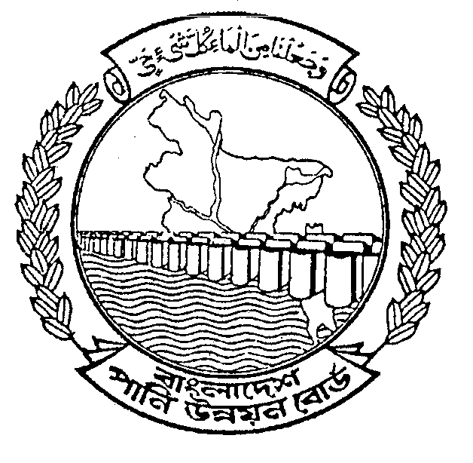
BANGLADESH WATER DEVELOPMENT BOARD
OFFICE OF THE
EXECUTIVE ENGINEER
BARISAL O&M DIVISION, BARISAL

INVITATION FOR TENDER

TENDER NOTICE NO.-01/2010-2011.

GOVERNMENT OF THE PEOPLE’S REPUBLIC OF BANGLADESH
1 | Ministry/Division |  | Ministry of Water Resources.
2 | Agency |  | Bangladesh Water Development Board.
3 | Procuring Entity Name |  | Executive Engineer, Barisal O&M Division, BWDB, Barisal.
4 | Procurement Entity code |  | -
5 | Procuring Entity District |  | Barisal
6 | Invitation for |  | Manufacturing, supplying, dumping & placing of C.C. block, supplying Geo-bag (empty) size 126kg & 175kg under Protection of Birsrestha Capt. Mohiuddin Jahangir Bridge & Syed Rahida-Mosarraf academy from the erosion of Sugandha river.
7 | Invitation Ref. No. |  | Memo No.T-3/2231 (100)
8 | Date |  | 24-10-2010
KEY INFORMATION
9 | Procurement Method |  | Open Tender Method(OTM)
FUNDING INFORMATION
10 | Budget and Source of Funds |  | Non-Development Revenue Budget (GOB).
11 | Development Partners  (if applicable) |  | Not applicable.
PARTICULAR INFORMATION
12 | Project Code (if applicable) |  | Not applicable.
13 | Project name. |  | (1) Protection of Birsrestha Capt. Mohiuddin Jahangir Bridge & Syed Rahida-Mosarraf academy from the erosion of Sugandha river.
14 | TENDER PACKAGE No. |  | 2(Two) Nos.
15 | Tender package name |  | (i) PACKAGE NO. BSL-B-W-01, (ii) PACKAGE NO. BSL-B-W-02.
16 | Tender Publication date |  | -
17 | Tender Last selling date& time. |  | 29 -11- 2010 Office hours.
18 | Tender closing date & time |  | 30 -11 -2010 up to 12.00 hours (noon).
19 | Tender Opening Date & time |  | 30-11-2010 at 12.30 hours.
20 | Name & Address of the office(s)  -Selling tender document  (Principal) |  | Sonali Bank Ltd, Sagardi Branch, Barisal.
20 | - Selling tender document others |  | Rupali Bank Ltd, Sagardi Branch, Barisal.  Janata Bank Ltd. Dilkusha Corporate Branch, 29, Dilkusha C/A, Dhaka.
20 | - Receiving tender document. |  | Office of The Executive Engineer, Barisal O&M Division, BWDB, Barisal.
20 | - Opening tender document |  | The Executive Engineer, Barisal O&M Division, BWDB, Barisal.
21 | Place/Date/Time of Pre-  Tender Meeting(optional) |  | Not applicable.
INFORMATION FOR TENDERER
22 | Eligibility of Tenderer |  |  | All Elegible Tenderer as per “The Public Procurement Regulation, 2008”
23 | Brief Description of works
Sl. No. | Identification of Package/Lot No. | Brief Description of works |  |  | Location  Upazilla/  District | Price of Tender Document (Tk) | Tender security amount in (Tk) | Completion  time in week/months
1 | 2 | 3 |  |  | 4 | 5 | 6 | 7
1) | PACKAGE NO. BSL-B-W-01 | Manufacturing, supplying, dumping & placing of C.C. block, filling & dumping of geo-bag for protection of Birsrestha Capt. Mohiuddin Jahangir Bridge & Syed Rahida-Mosarraf academy from the erosion of Sugandha river.M 0.00 to 105.00M= 105.00M in Upazilla Babugonj, Dist Barisal under Non-development Revenue Budget under Barisal O&M Division, BWDB, Barisal during the year 2010-2011. |  |  | Babugonj/  Barisal | 1500/-  Per set (Non-refundable) | 150000/- | 6 months

-2-

Sl. No. | Identification of Package/Lot No. |  |  | Brief Description of works |  | Location  Upazilla/  District |  | Price of Tender Document (Tk) | Tender security amount in (Tk) | Completion  time in week/months
1 | 2 |  |  | 3 |  | 4 |  | 5 | 6 | 7
2) | PACKAGE NO. BSL-B-W-02 |  |  | Supplying non-woven needle punched geo-textile (empty) bag (Geo-bag size = 1030mmX700mm; Thickness=> 3.00mm, Fill vol = 0.084cum; wt =126kg) & (Geo-bag size = 1150mmX800mm; Ge-fabrics Thickness=> 3.00mm; Fill vol = 0.1167 cum; wt =175kg) for Protection of Bir Srestha Capt. Mohiuddin Jahangir Bridge & Syed Rahida-Mosarraf Academy from the erosion of Sugandha river from M 0.00 to 105.00M= 105.00M in Upazilla Babugonj Dist Barisal under Non-development Revenue Budget under Barisal O&M Division, BWDB, Barisal during the year 2010-2011. |  | Babugonj/  Barisal |  | 750/-  Per set (Non-refundable) | 120000/- | 5 months
 | PROCUREMENT ENTITY DETAILS
24 | Name of official inviting tender |  |  |  | MD. HARUNUR RASHID.
25 | Designation of official inviting tender |  |  |  | Executive Engineer,
26 | Address of Official Inviting tender |  |  |  | Barisal O&M Division, BWDB, Barisal.
27 | Contract details of Official Inviting tender |  |  |  | Telephone No. 0431-72233(Office)
28 |  | Special Instruction | (a)The procuring Entity reserves the right to accept or reject any or all tenders without assigning any reason.  (b) If any confusion arises due to printing mistakes in STD PW-2 & PG-3 or otherwise, than “The procedure for implementation of the Public Procurement Regulations-2008” will govern.  (c) Payment will be made as per availability of fund.  (d) The regulation laid down in the “Public Procurement Regulation 2008”. The Procedures for implementation of the PPR-2008 and the Standard Tender Document (STD PW-2& PG-3) shall be in strict compliance..  (e) The tender security in the form of demand draft/pay order/Bank guarantee must be submitted City area of Barisal Town in favor of the Accounts Officer, Regional Accounting Centre, BWDB, Barisal.  (f) In case of geo-textile bag supply sample of size 30cmX30cm with test result of Manufacturing Company should submit with the tender document.  (g) If it is proved at any stage that information furnished in the tender by the tenderer is false and the tender is signed and submitted in a way of fraudulent instead of singing the same by the actual tenderer/their authorized signatory, their tender/work order will be outright and action will be taken according to PPR-2008.

N.B: The tender notice is available in the website www.bwdb.gov.bd for Bangladesh Water Development Board.

(MD HARUNUR RASHID)
Executive Engineer
Barisal O&M Division
BWDB, Barisal.

